Dear Sir or Madam,

We cordially invite you to participate as a Sponsor for our first ever Kenwood Cares 5k Race, Youth Run, and Spaghetti Dinner/Auction on April 12th, 2014. Our goal is to make the Kenwood Cares 5k an annual event and we are actively seeking partner organizations that can serve as event sponsors.

Kenwood Elementary in Champaign, IL is a public school that serves close to 400 students from Kindergarten to Fifth grade. This school year, we tragically lost one of our First Grade teachers, Paula Gaddis, at the age of 34. Paula grew up in Tolono, IL and would have loved to run for a good cause. She leaves behind a loving husband and four wonderful children. This year, our Race and Spaghetti Dinner/Auction’s proceeds will benefit her family and recognize Paula’s love for running.

We invite you to consider joining us as a sponsor and partner with us in an effort to support our school, community, and the family of our beloved teacher, Paula Gaddis. With this letter, we’ve included a Sponsorship Commitment Form with more detailed information. We are committed to actively promoting every sponsor who will help make this a successful event.

If you have any questions about the race or the available sponsorship opportunities, please do not hesitate to contact us. We look forward to your help in promoting healthy, active living and sponsoring a fun, positive event for our whole community. Thank you for the gift of support and sponsorship.
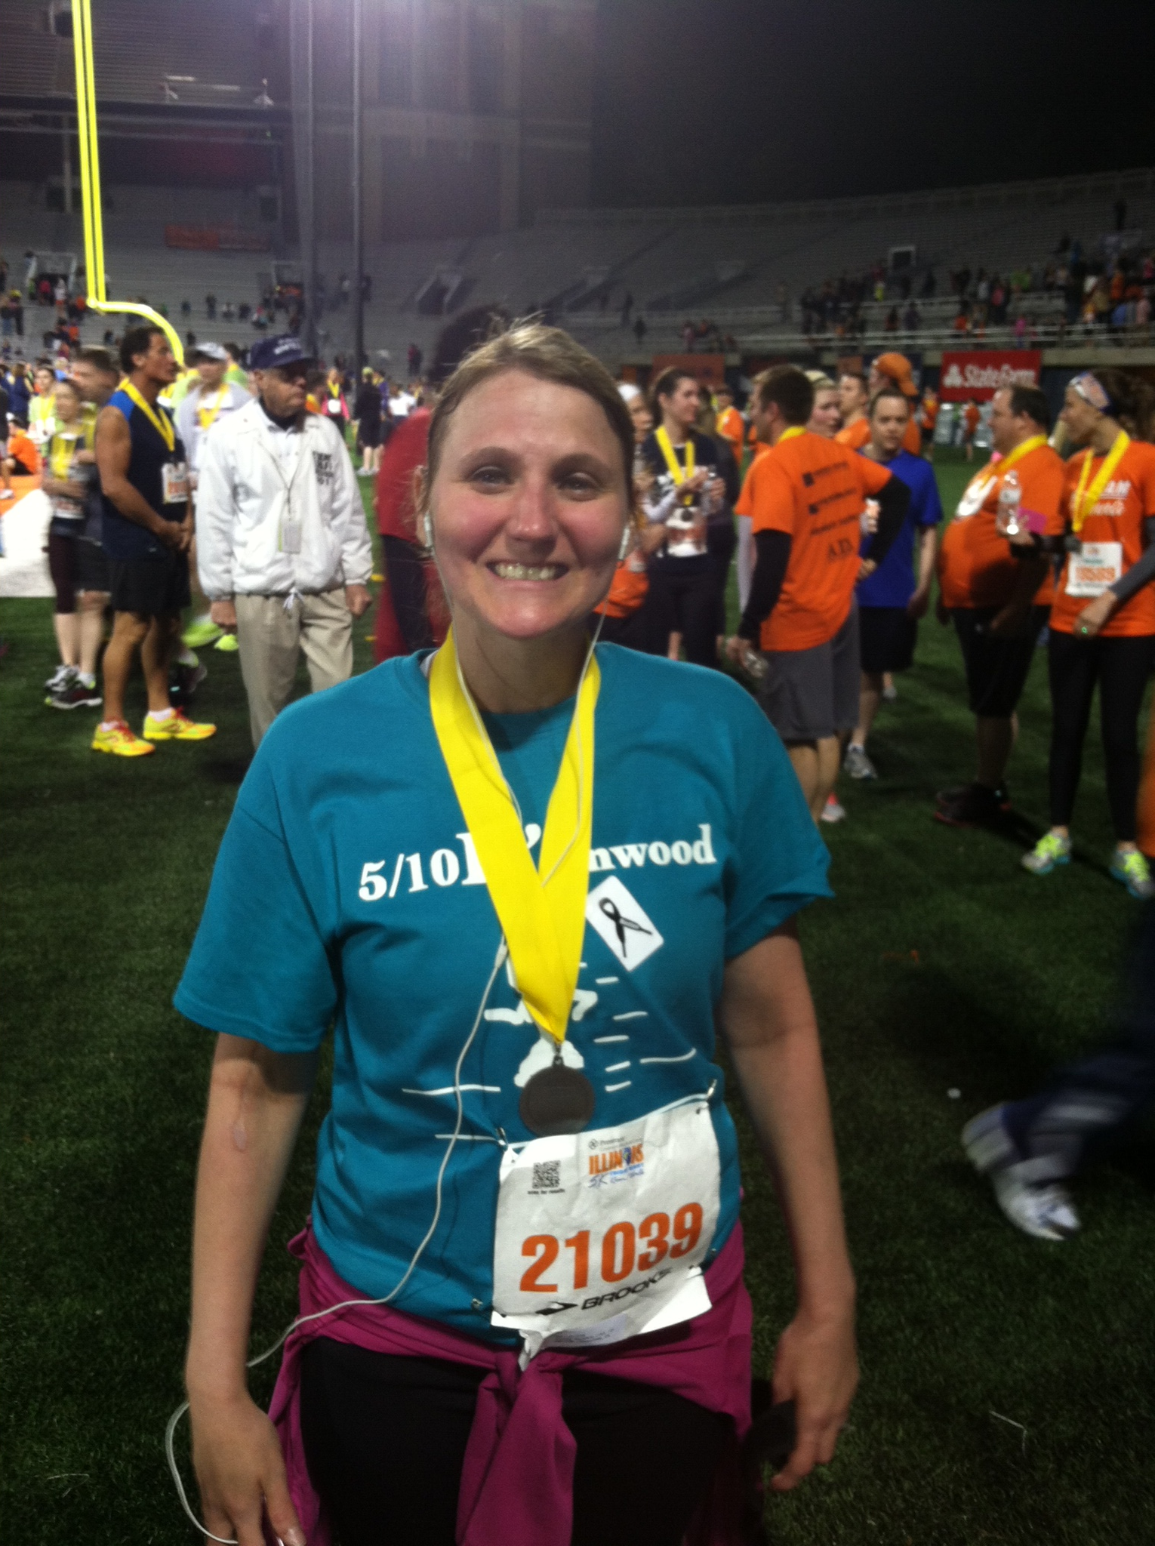

Sincerely,

Lisa Geren
Principal

Paula finishing the Illinois Marathon 5k in 2013
SPONSORSHIP LEVELS

Sponsorships and payment must be secured by March 7, 2014 in order to receive the full list of benefits. Any sponsorships after March 7, 2014, will receive as many of the benefits as possible pending printing timelines.

Gold - $500
- Includes everything in Silver sponsorship PLUS:
- Large logo on shirt
- Banner on start and finish line

Silver - $250
- Includes everything in Bronze sponsorship PLUS:
- Recognition on Flyers
- Small logo on Shirt

Bronze - $100
- Company logo/name on race program
- Company logo/name on website
- Recognition during Spaghetti Dinner

Purple - Other (Monetary or Services)
- Company logo/name on race program
- Company logo/name on website

Kenwood Cares 5k and Spaghetti Dinner/Auction
Champaign, IL

Kenwood Elementary Saturday, April 12, 2014

SPONSORSHIP FORM
Please return by March 7, 2014 to take advantage of all of these benefits.

Please select sponsorship level:

□ Gold - $500
- Includes everything in Silver sponsorship PLUS:
- Large logo on shirt
- Banner on start and finish line

□ Silver - $250
- Includes everything in Bronze sponsorship PLUS:
- Recognition on Flyers
- Small logo on Shirt
□ Bronze - $100
- Company logo/name on program
- Company logo/name on website
- Recognition during Spaghetti Dinner

□ Purple - Other (Monetary or Services)
- Company logo/name on program
- Company logo/name on website

RESERVATION AND CONTACT INFORMATION

□ Enclosed is my check made out to “Kenwood Elementary School” for $__________________

NAME______________________________________________________TITLE____________________________________

COMPANY_________________________________________________CONTACT________________________________

ADDRESS______________________________________________________________

CITY/STATE/ZIP________________________________ PHONE___________________________________

EMAIL ___________________________________________
Please make checks payable to: Kenwood Elementary School
Mail to:
Kenwood Elementary School
1001 S. Stratford Dr.
Champaign, IL 61821

